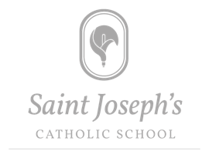
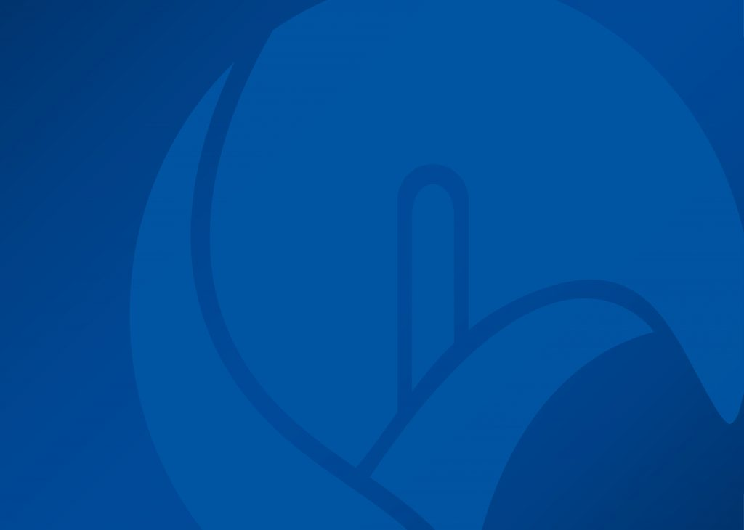
Whole School PSHE, including RSE Sessions – 2025/26

Colour Coding:

Introduction to PSHE (Relationships) | Life Skills (Living in Our Wider World) | Healthy Lifestyles (Health and Wellbeing) | Careers Education Information Advice and Guidance (Living in Our Wider World) | RSE (Relationships and Sex Education) | British Values (Living in Our Wider World)

PSHE Sessions 2025/26:

Date (WB) | Year 7 | Year 8 | Year 9 | Year 10 | Year 11
1st Half Term, from week 1 beginning:
Sept 1st | SJCS PSHE Introduction:  What kind of pupils do we want at St Joseph’s? | Positive Mental Health 1: What are attitudes to mental health? | FLIC Session 1:  Mobile Phones | Healthy Lifestyle: Positive Mental Health 1 | CEIAG Lesson 1 – Post-16 Options; what do I need to consider?
Sept 15th | Healthy Start: Lifestyle and Healthy Eating | PMH2: What is emotional wellbeing and resilience? | FLIC Session 2: Cryptocurrency | Healthy Lifestyle: Positive Mental Health 2 | CEIAG 2: Which option Is best for me?
Sept 29th | Healthy Start: Why is a good night’s sleep important? | PMH3: What is digital resilience? | FLIC Session 3:  Financial Exploitation | Positive Mental Health 3 | CEIAG 3: Intended Destinations (Round 1)
Oct 13th | Healthy Start: Strategies for healthy sleep | PHM4: Healthy coping strategies | FLIC Session 4: Online Gaming | Drugs Education 1: Talk About Drugs Influences and Choices | FLIC 1: Take Home Pay
2nd Half Term
Nov 10th | Healthy Start: Dental Health Yay! | What is a Healthy Lifestyle? What are the blockers to a Healthy Lifestyle? | Belonging and Community Lesson 1: Identity and Community | Drugs Education 2: Talk About Cannabis | FLIC 2: Budgeting
Nov 24th | Financial Literacy and Inclusion Campaign 1:  Spending decisions | Alcohol Awareness 1: Why do some choose to drink? | B and C Lesson 2:  Lesson 2:  Bias and Stereoypes | Drugs Education 3: Talk About Vaping | FLIC 3: Savings accounts
Dec 8th | FLIC 2: Budgeting | AA2: How many units? | B and C Lesson 3:  Discrimination and the Protected Characteristics | Drugs Education 4: Talk About Drugs: Where’s the Harm? | Study Skills: Active Revision
3rd Half Term
Tuesday  Jan 6th | FLIC 3: The Critical Consumer | AA3: What are the physical and social effects of drinking? | RSE1: The search for love | CEIAG 1: Skills and Qualities | Mocks – active revision if not in exam
Jan 19th | CEIAG: What is CEIAG? | AA4: Alcohol and the Law | CEAIG 1: Options Introduction (Hall) | CEIAG 2: Work Experience introduction | RSE 2: Addiction
Feb 2nd | My Skills and Qualities – and Bob’s Jobs! | AA5: The effects of drinking too much | RSE 2: Love people use things | CEIAG 3: Mock Interview Prep: Covering Letters | RSE 3: Control (Eating Disorder)
4th Half Term
Feb 23rd | RSE 1: Who am I?  Appreciating difference and core identity | RSE 1: Created and chosen: becoming aware of our uniqueness | RSE 4: Fertility and contraception | RSE 1: Authentic freedom | RSE 5: Pornography
March 9th | RSE 2:  Changing bodies: Puberty– daunting, but part of God’s plan | RSE 2: Appreciating difference: understanding our identities | RSE 6: Understanding consent | RSE 2: Self Image: understanding our dignity | RSE 6: Keeping Safe: STIs
March 23rd | RSE 4: Where we come from | RSE 3: Feelings: managing feelings requires self-control, self-respect and patience | RSE 7: Human Rights – and Wrongs | RSE 4: Parenthood | RSE 7: Coercive Control
5th Half Term
April 20th | RSE 5: Family and Friends: Different types of friendship and family structures | RSE 4: Before I was born: contemplating life in the womb reveals that it is both beautiful and fragile | Gambling Awareness 1:How can we manage risk? | RSE 5: Pregnancy and abortion | Belonging and Community: Lesson 1;  Valuing Diversity
May 5th | RSE 6- My Life on Screen: Online lives need safeguarding, just like in real life | RSE 6: Think Before You Share | Gambling Awareness 2: : How can we manage impulsive behaviour? | RSE 6: Abuse | B&C Lesson 2: Understanding and preventing extremism
May 18th | Introduction to British Values | British Values: The Rule of Law 1 | Gambling Awareness 3: How can we help people who have developed problems with gambling? | RSE 7: Solidarity | B&C Lesson 3: How are people drawn into extremist groups?
6th Half Term
June 8th | British Values: Democracy | British Values: The Criminal Justice Systm | Gambling Awareness 4: How can we challenge the gambling industry? | WEX final prep | Active revision
June 22nd | British Values: Tolerance | CEIAG 1: Careers Exploration and Options Log | British Values: Democracy revisited | British Values Revisited | No longer in school
July 6th | Staying Safe: Road and Rail Safety this summer! | CEIAG 2: The Buzz Test | BV2 : How does democracy work in the UK? | British Values Mutual Respect and Tolerance | No longer in school
July 20th | Year 7 PSHE audit | Year 8 PSHE Audit | Year 9 PSHE audit | Year 10 PSHE/WEX Audit | No longer in school

FLIC for Year 9 financial literacy focusses on issues that they may come across in their lives going forward. It’s the ideal year to do this in. FLIC stands for the Financial Literacy and Inclusion Campaign, resources supported by the Financial Times, hereafter FLIC
The Talk About Trust are an award winning charity that works across the UK to ensure young people make safer choices around alcohol and other substances such as vaping and cannabis. St Joseph’s have used their alcohol education resources with great effect in Year 8 for many years.
All RSE will now be delivered within PSHE as opposed to RE. We will continue to use TenTen resources which have been proved to be very effective in the past, and all parents/carers will retain the right to access the TenTen Parent Portal.
Year 7 will also have a tutor time session with Ms Gale, Lead Careers Professional regarding CareerPilot and how to use it.

